Install MySQL on **WINDOWS**

1. Go to MYSQL downloads link: <https://dev.mysql.com/downloads/>
2. Click on “*MySQL Installer for Windows*” link.
3. Choose this option:



Note – the above [although it says 32-bit] will work for both 32 and 64-bit computers. This option is the actual installer.

1. Click on the above ‘Download’ button.
2. You will see this. Go to ‘*No thanks, just start my download*’ as shown below:Graphical user interface, text, application

   Description automatically generated
3. It will download the file.
4. Double click the file and **start** the installation process. You will see this.

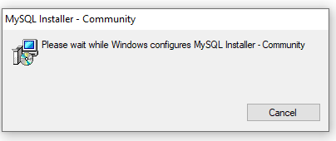

1. When you come at … ‘Choose a setup type’ select **Custom** and click Next

1. You will now be able to select what products you would want to install.
2. Click on MySQL Server – **Keep** on expanding and it will tell you the latest version. Drag this to the right-hand side for installing this.

NOTE – In this image, it’s an old screenshot and hence it’s showing MYSQL Server 5.7. You would see something like 8.0.31 (latest version).

1. Go to Applications => MySQL Shell. Install this too, as shown below:

1. Again, within Applications => MySQL Workbench 8.0. Install this too, as shown below. Click Next

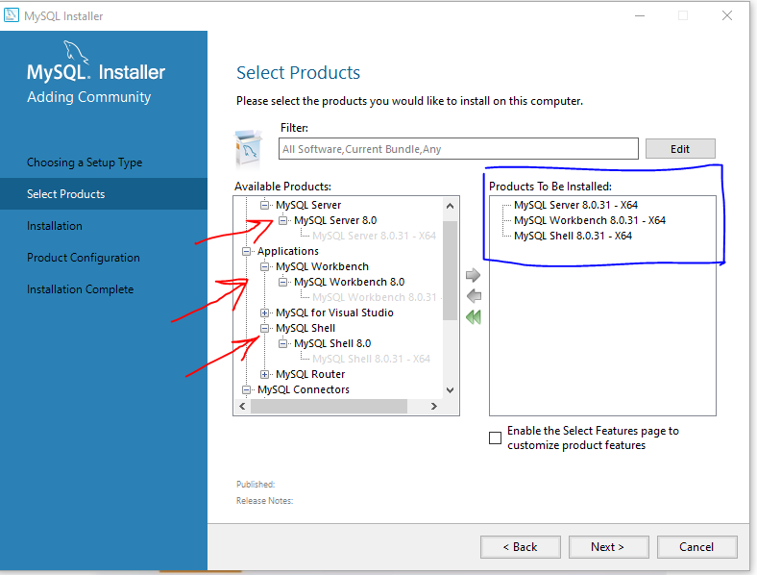

1. We will be downloading the above three options (MySQL Server + shell + Workbench). Click on **Execute** button, as shown here:

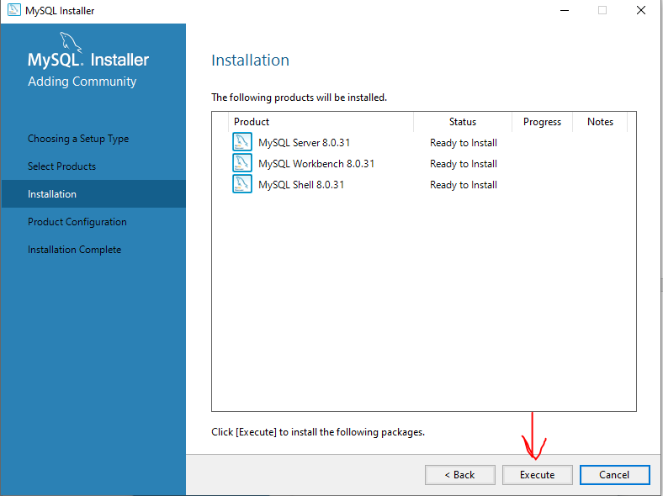

1. It will begin downloading. You can monitor the progress:

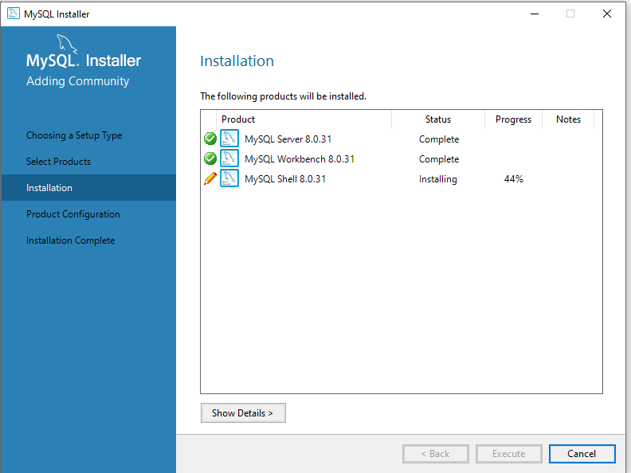

1. Once the installation is complete, Click ‘Next’.
2. You will come to the “Product Configuration” page. Click Next

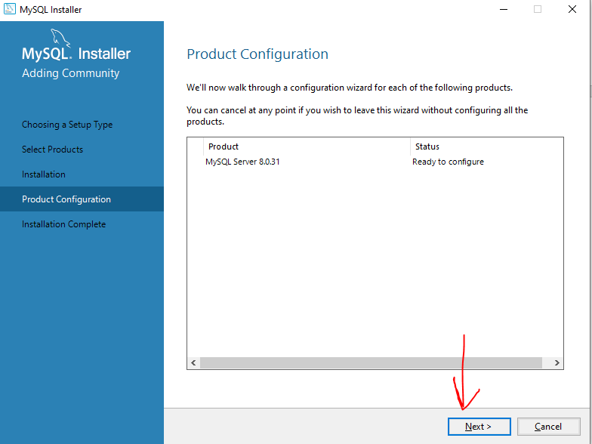

1. On ‘Type and Networking’ page, don’t change any settings, and click ‘Next’.

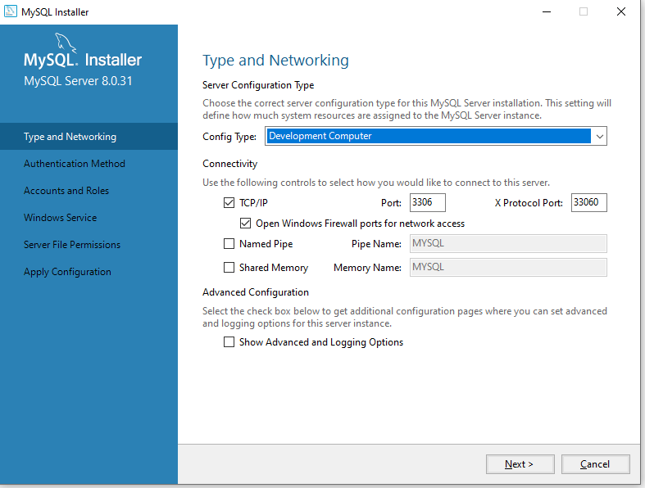

1. On “Authentication Method” page, don’t change anything, and press ‘Next’

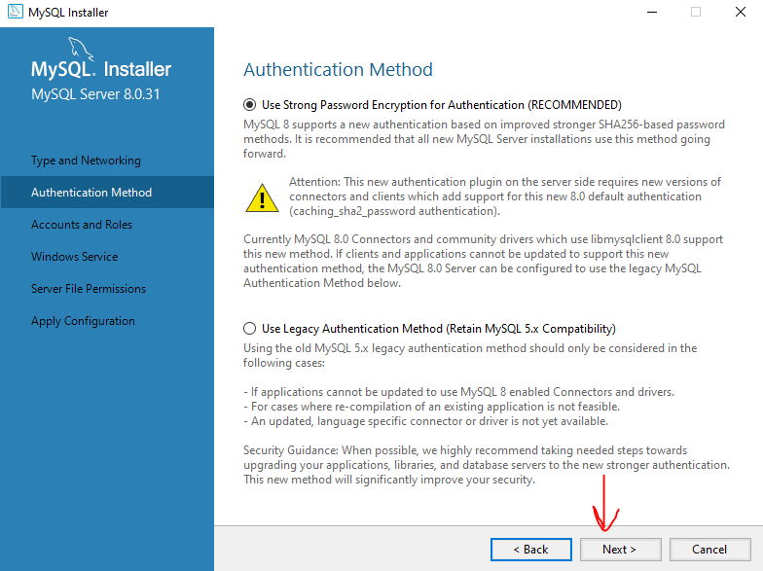

1. On “*Accounts and Roles*” page, enter the MySQL root password and confirm password values, and press ‘Next’

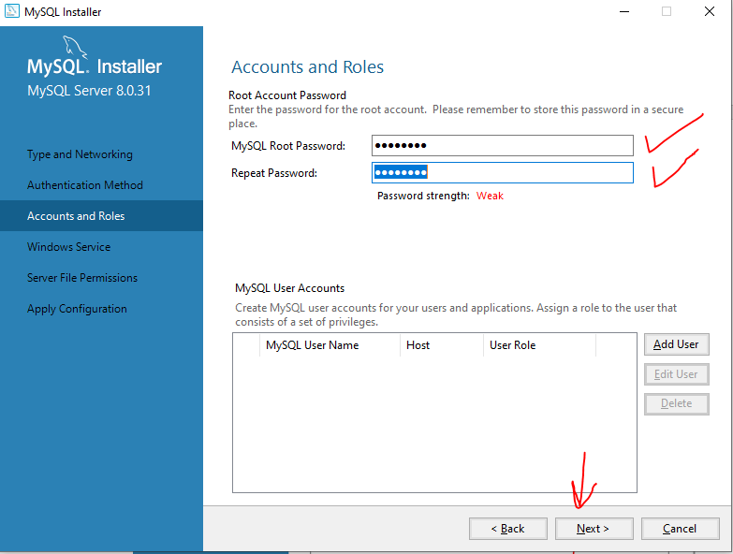

1. **Make sure you remember this password as we will use it later.** Kindly note down the password somewhere.
2. On “Windows Service page, don’t change anything. Click ‘Next’.

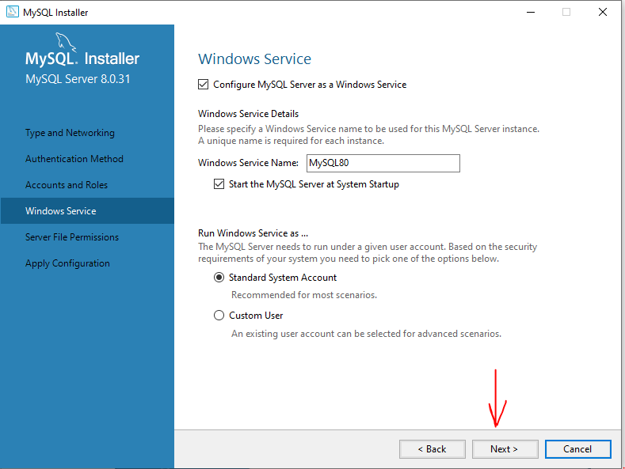

1. On “Server File Permissions” page, don’t change anything. Click ‘Next’

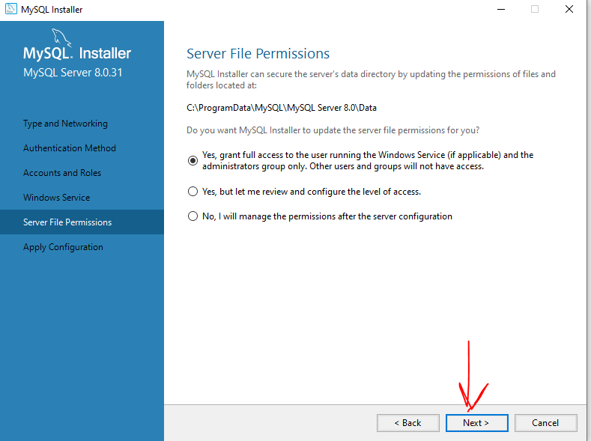

1. On “Apply Configuration” page, simply click on ‘Execute’.

1. We are almost done. Click **Finish,** as shown below:

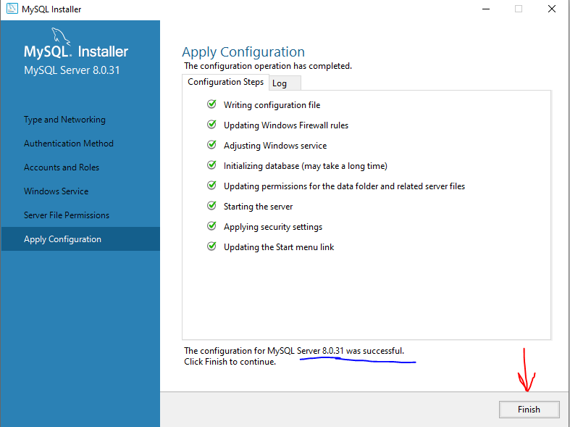

1. On the “*Product Configuration*” page, click ‘Next’

1. Installation is complete. Click ‘**Finish’.**

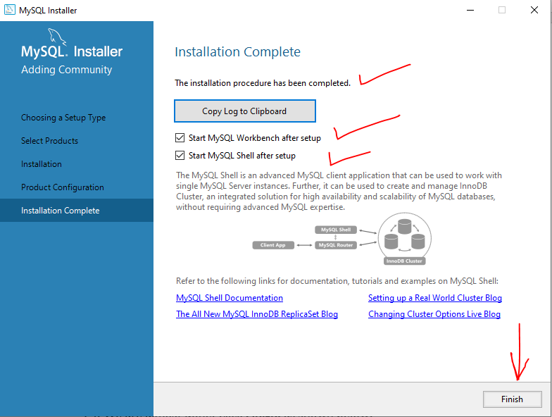

1. Once you click Finish, you will see two windows [shown below]– one for Windows shell, and the other for MySQL Workbench, kindly close them.

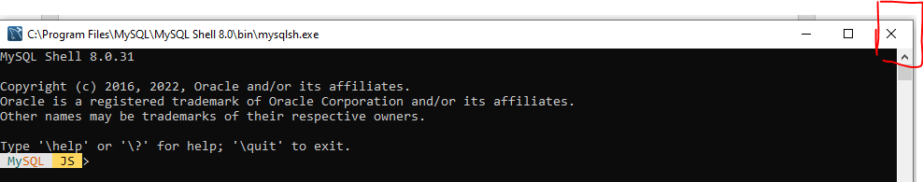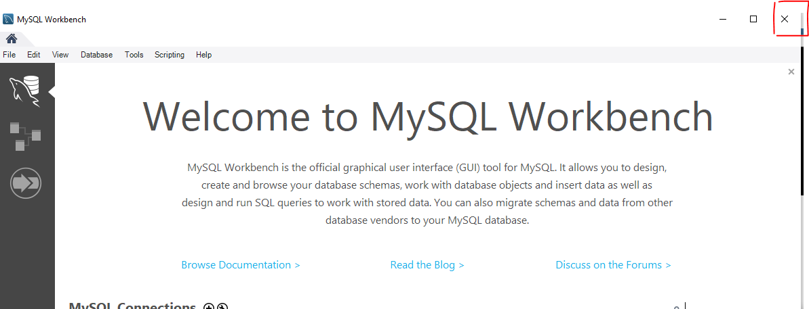

1. Running the program. Click on ‘Windows logo’ key (on the keyboard) and choose the Command Line Client.

Kindly ignore the version number here.

1. This will open a command line window and will prompt you to enter the password. Please enter the password you had set up on point 19.

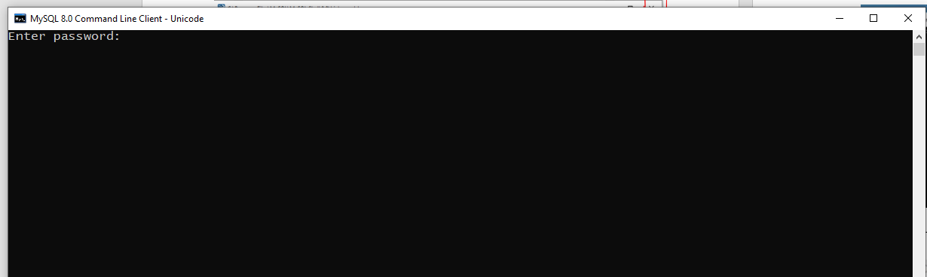

1. After entering the correct password, you will see this screen:

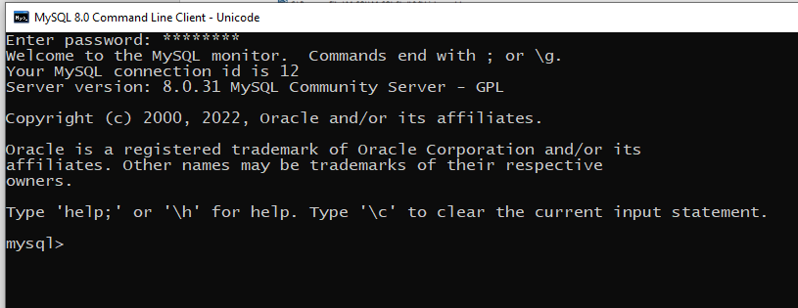

1. Now, we are connected to the MySQL server that is running on our computer.
2. ALL DONE!!!!

Git, Github Github for desktop; <https://www.youtube.com/watch?v=8Dd7KRpKeaE>